Alumni Blog – August
Back to School: Are you Prepared?

Summer break is quickly coming to an end, and some of you may be excited to get back to campus to see all of your friends and favorite professors. Some of you may be stepping foot on campus for the first time and may be a little nervous about the upcoming year. College may in fact present more challenges and experiences than high school, but being prepared for this transition can help students thrive on their first day back to college or on their first day starting college.
If you are wanting to gain more confidence and feel more excited for your first day of school, follow these tips that can help you feel more prepared to be back!
Plan to Arrive Early

If you arrive at school early, you have enough time to unpack all of your belongings and prepare your dorm to your liking. This helps you feel more comfortable and at home because you have time to get settled in before classes start. It can also take some time to get used to if you are a first-year college student, so you want to have time to get comfortable in that space. You also want to have time to get to know your roommate before you are both busy and never have the time to get acquainted. Go to the movies, go roller-skating, or go hiking! They just might end up being your best friend throughout college!
Review Your Class Schedule Beforehand
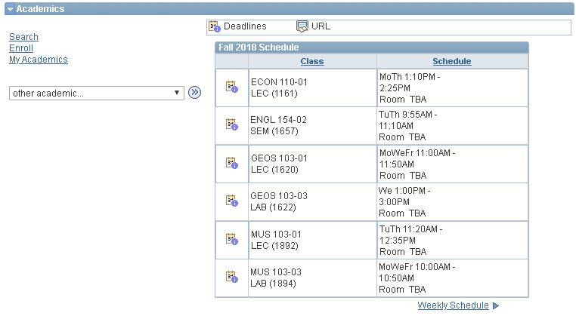

When you get situated on campus, look over your class schedule. See who your professors are, study up on the class itself, and make sure you need or want those courses. You can also see what books you will need to have for each class and you can start looking for them in the library. Some professors might even tell you that you don’t need a specific book, so it is best to wait until after your first class to purchase them in some cases. You can also ask around about your professors to see what experiences other people have had with them. You may even want to take a class with a specific professor because other people talk so highly of them!
Familiarize Yourself with Class Locations

Once you have taken a look at your class schedule, it would be a great idea to try to find your classrooms before the first day of class. You could save yourself some time and stress by locating them ahead of time. You definitely do not want to be late on your first day of college! Familiarizing yourself with these locations could ease some nerves you have about beginning college for the first time and help you on down the road.
Prepare for Note-Taking

Before your classes begin, make sure to have notebooks or binders for all of your classes, pencils, pens, highlighters, sticky notes, and any other school supply you may need. You will definitely want to take notes on important due dates and other information on the first day of class, so you will need those items. All of the professors will be throwing out a lot of information at you from the syllabus, but taking notes will help you remember the most important things.
Anticipate Making New Friends

If you are a first-year college student, you may feel a little nervous about going to a school where you do not know a single person. It can feel very intimidating, but odds are, you are not the only one to feel that way! When you get into your classes, try introducing yourself to your classmates. If you get to know your peers, it can make it easier to make new friends and form study groups to tackle challenging assignments. You will get used to talking to new people and forming friendships as you go along, but it can be a step out of your comfort zone the first couple of times.

Those first day jitters will soon go away when you get established into a routine, and you will begin to enjoy all of the aspects of college life. You will learn how to navigate relationships, schoolwork, and living away from home as time goes on. While the first day of school can often times be nerve-racking, it is an exciting new adventure that will teach you about independence, responsibility, and scholarship.

Enjoy this time in your life!

