Building Your Resume in College

As you get closer to graduating college, you are getting closer to entering the job market. One of the first things your future employer will want to see is your RESUME! This will give them a brief snapshot of your education, work history, and personal summary. As a college student, you’re already working on the education section, but what about the other sections of the Resume? When should you start building a personal summary or work history? Now! Now is the time to build your resume! You will want to have your resume filled up BEFORE you graduate so you can more easily step into those jobs you have been working so hard to educate yourself for!

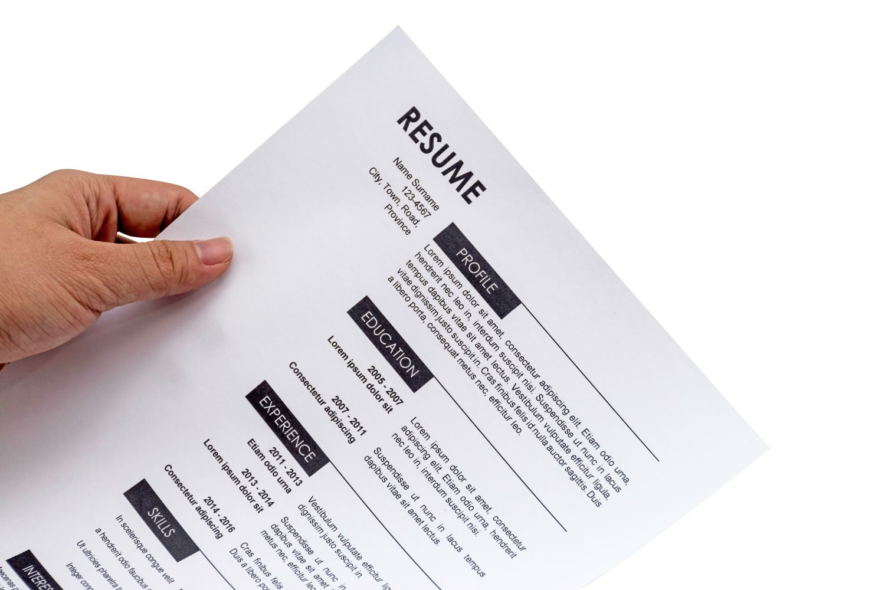

Here are some suggestions and possible things you can do to build your resume while in college:

- Get an on-campus job. Options include working at the gym, dining hall employee, RA (Residential Adviser), summer orientation crew, college tour guide, office worker, library worker, tutor, working the desk at dorms, IT worker, etc. There are so many on-campus jobs to choose from! And the great thing about campus jobs is that they work with your class schedule, and they only schedule you for about 20 hours a week (so you have plenty of time to be a student, study, etc.) You will do a lot of networking and you will be able to build your reference sheet (a list of people your future employer can contact to learn more about you).
- Take leadership roles in student clubs and organizations. Being President / Vice President / Secretary / Treasurer / etc. in a student org gives you lots of experience that employers are attracted to. Some of these experiences could be planning and organizing meetings, events, or fundraisers, running social media pages, marketing, recruiting, mentoring, etc. Taking on these roles is a great way to build the leadership skills you probably wouldn’t be making in the classroom alone.
- Play a sport! Student-athletes are respected in the job market. The lives of these students are very disciplined. Most athletes have to go to practices, study hall, keep up with their diet and exercise, and keep their grades up in order to compete. Actions speak louder than words: rather than saying you’re hard-working and driven, your success as a student-athlete says it for you.
- Do an internship. One of the best ways to get your foot in the door is to intern at a place you would like to work! Many internships end with a job offer. It’s a way to get real-world experience and learn about the industry before graduation. Plus it’s a great way to network and get to know the future coworkers and employers you will be working with in the future.
  - If your desired workplace doesn’t offer internships, you can always call and ask to job shadow for the day to learn more about the day-to-day operations. You never know what might open up if you click with the people .
- Study abroad. Not only is this fun and allows you to travel, but it helps you become more worldly and network with people you most likely wouldn’t have met otherwise. It gives you experience and a set of skills many other job candidates may not have.
- Get certificates in the industry you want to join. Many industries have exams, certifications, or licenses people have to get before they can fully do the job. Many colleges help you start working on the credentials while still a student to get ahead of the game. Plus it shows that you’re serious about joining the industry!
  - At the next job fair, ask the employers in your desired industry what THEY want in job candidates. Some companies prefer one certificate to another.
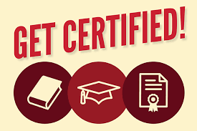
- Get involved! Be a member of different clubs, organizations, church groups, volunteering, etc. You can list the clubs you participated in as a filler if you need to get rid of some empty space on your resume. Plus, maybe one of those clubs pops out to your employer and shows them you have shared interests. That could spark up some conversation, and make you more memorable and likable than other job candidates. You will meet a lot of people, gain a lot of experience, and have more opportunities for fun than college students who choose not to be involved. College can fly by really quickly, so getting involved can really help you enjoy and make the most out of the few years you spend there.

