Tips for Writing College Papers/Reports
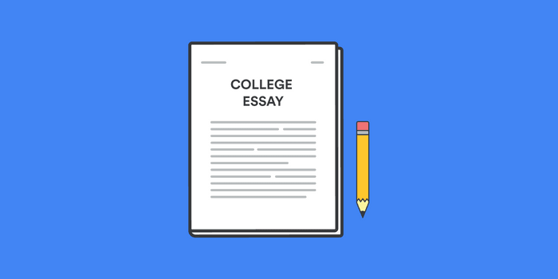
- Start Early! You need time to brainstorm, lay out your paper, do the research, get some quotes, make a rough draft, and edit/revise the final draft. Trying to write a full paper (especially one that requires lots of research) a day before it is due will not end well. Giving yourself plenty of time to work on it will help ensure you fully answer the prompt and attempt to get EVERY point towards your grade.
- FOLLOW THE INSTRUCTIONS! So many of us make the mistake of misreading the instructions and losing points for something as simple as the size/font of the paper! Make sure you’re following the format requirements of the assignment. Also, make sure you answer all parts of the questions! So often, we overlook small parts of a question and lose out on points. Even if you don’t fully know the answer, it’s better to attempt to answer the question and get partial credit than to get no credit for that section.
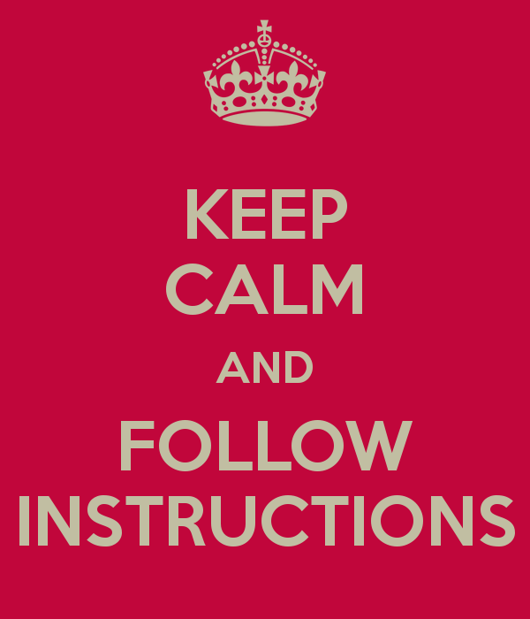
- Go to the tutoring / writing center at your college. They have students or professors who will help you edit your paper all the way from the grammar, to the overall flow and structure of your paper. They can help you say what you need to say! Even if you can’t get an appointment in the writing lab, you can ask a friend, roommate, RA, or someone else to read over your paper. It always helps to get a second pair of eyes on a project to see if it makes sense to a third party.
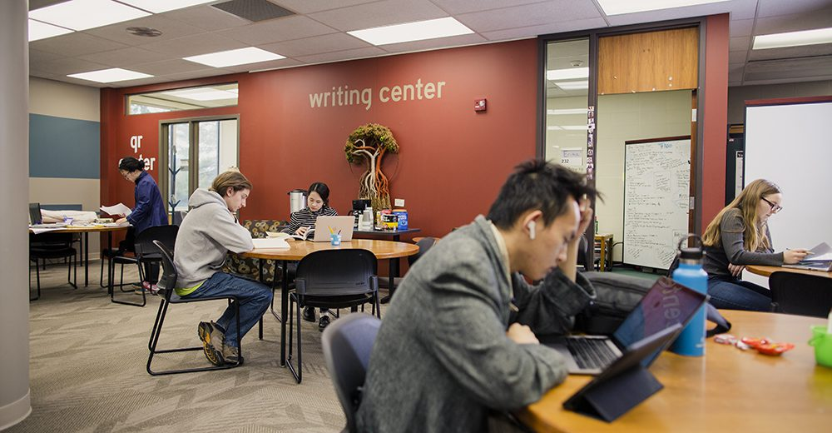
- Take a break! You get used to rereading the same thing over and over, and your brain WILL play tricks on you. Simply not looking at it for 2 days will refresh you and make you better able to edit and sharpen up your final papers. (This is another reason why it’s important to START EARLY!) And when you do come back from taking a break, make sure to read it slowly word for word out loud so you can see how it sounds to someone else.
- Following that last point, read your paper out loud to yourself! When you start stumbling over a particular section while reading a paper out loud, it’s a good indication that it could be written better. The more simply and clearly you can articulate your points, the better. Lots of times, professors have to grade hundreds of papers all at once, so they aren’t going to spend an excess of time trying to decipher what you’re talking about. Instead, they will assume you didn’t understand the assignment, mark points off, and move on.
- When revising and editing, try reading the paper out of order. We get used to reading the paper from beginning to end over and over and can start to zone out. You can try reading your paper from end to beginning (start with the last paragraph, then back up to the next to last paragraph, then the paragraph before that, etc.). This will give you a different angle of looking at it, and take away some of the repetitiveness of reading the same paragraphs in the same order. Our brain starts to memorize the paper when we read it over and over beginning to end. Your brain will mistake a section as sounding good when really it just sounds familiar. Reading it out of order tricks your brain into thinking it’s unfamiliar information and allows you to more sharply focus instead of
skimming. This could help you catch mistakes you otherwise would have overread.
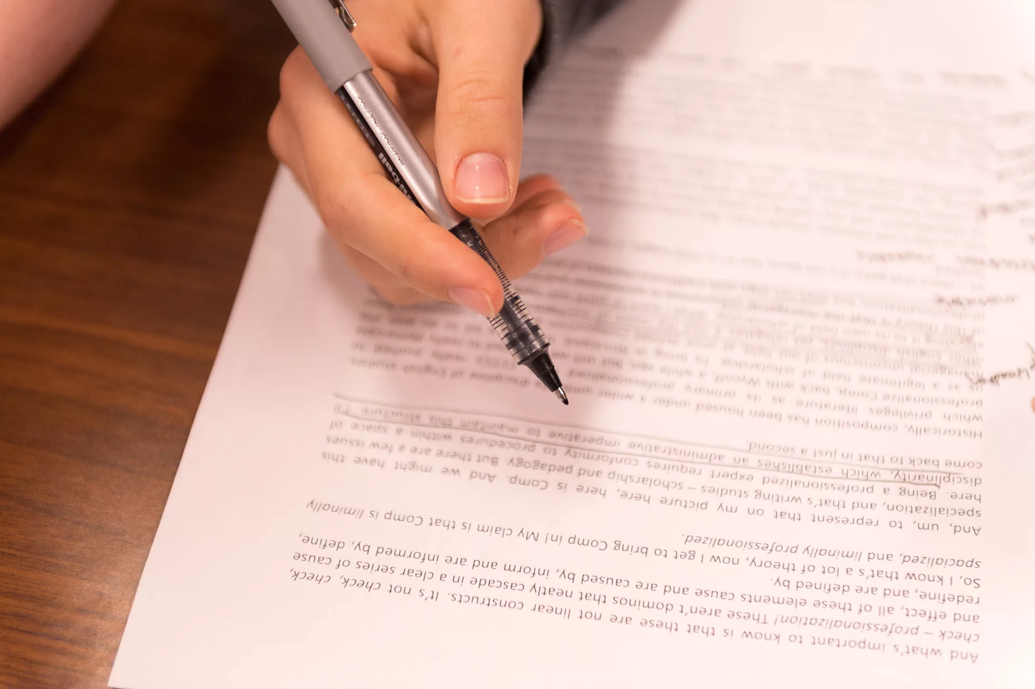
- Lastly, TURN IT IN ON TIME! Yes, some professors will allow you to turn in assignments late (though some DON’T), but you will automatically lose points for turning it in late! Every point counts, so turning in your paper before 11:59 PM can be the difference between passing a class, or having to retake it next year!

