Go Outside!

Simply going outside CAN improve your mental and physical health and wellness. In today’s world, people spend most of their time indoors and on screens. Instead, take a break from the norm, unplug from your screens, and go soak up some sun!! Here are some positive things you can receive by going outside:
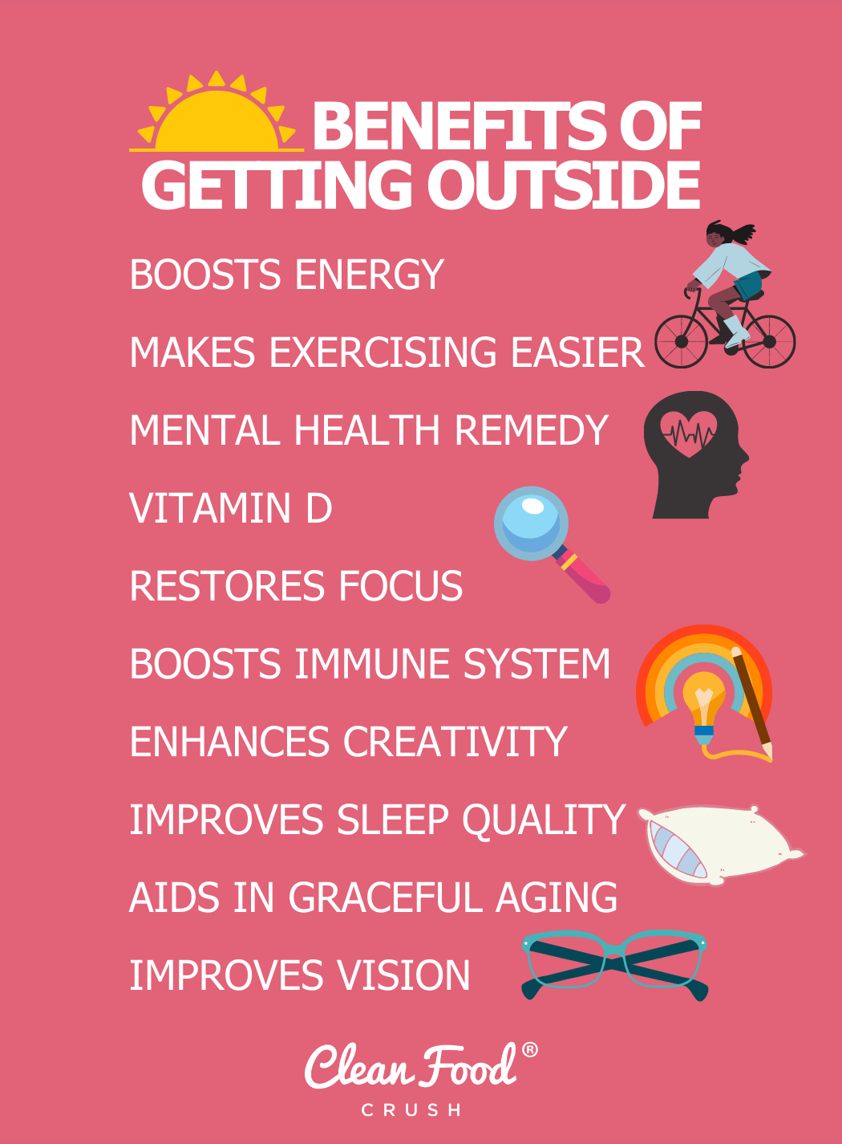

- Exercise. There are so many ways to exercise outdoors. You can go for a walk or run in the park, play sports with friends, take a hike, do some yard work, walk your dog, go swimming, ride a bike, and so much more. Take your pick! Get out there, move your body, and have fun!
- Vitamin D. One of the best sources of Vitamin D is the sun. Just a short amount of time outdoors can be a healthy source of Vitamin D, which you wouldn’t get from food alone. This doesn’t mean you need to stay in the sun ALL day and get sunburned, but a few minutes outside could be a good Vitamin D burst.
- Mood improvement/stress relief. “Researchers have found that nature simply makes us happy and decreases anxiety, depression, and anger.” Being in the quiet, breathing fresh air, soaking up some sun, and watching the wildlife can all be relaxing. It helps to just step away from all the to-do lists and take a break from the noise and stress. Being able to relieve some stress also lowers your blood pressure. So if going outside can take away some stress, you’ll be benefiting your mental and physical health in one act.
  - Plus, lowering stress boosts productivity. Instead of spending countless stress-filled hours trying to get your work done, just spend a few quality and productive hours on your work. That hour or 2 spent outdoors destressing could save you hours of stress-filled work.
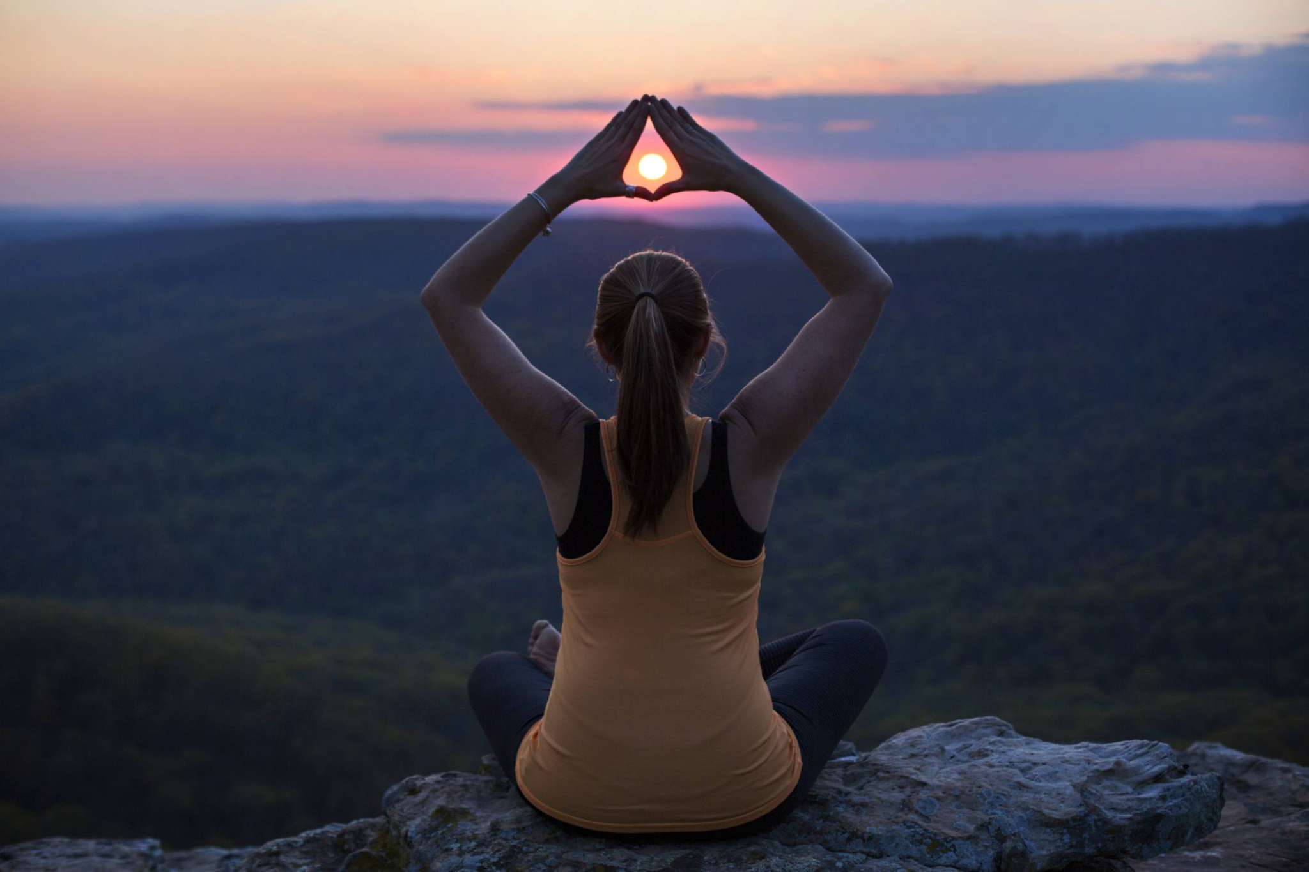
- Boost the immune system. “Being outside also improves our immune systems. This is especially important for children, as it helps them build up their natural resistances. When children come into contact with dirt, bacteria, and animals during outside play, they are helping to reduce the risks of allergies and autoimmune diseases in the future.”
- Lastly, it's free!! Taking OTC vitamins and going to the gym is also good for you, but they usually cost some money. Whereas, going for a run outdoors is free, and gives you some free Vitamin D from the sun. Save some money and simply go outside for your health!

