Fall Semester Reset

Each Fall is a chance to reset and have a better year in college. Take some time to reflect on your progress and how you may be able to improve this year. By now, you’ve become familiar with how the campus is laid out, the college routine and pace, how to study (or not to study), and even got to know some of the professors you may be taking classes with. With this information, you should be able to see some areas of inefficiency you can optimize this new school year.

Take advantage of the writing centers or tutoring labs on your campus. They’ll be able to help you significantly improve your grades if you use them appropriately. Most students don’t utilize all the free resources available to them in college. Now’s your chance to change and get the most out of what you’re paying for.

Have you found a good study space on campus? Do you work better in your room, or at the library, or in the coffee shop? Find your spot to study and stick to it. Our brains like habits. If you keep going to the same spot when it's study time, your brain will remember the environment and know it’s time to get down to business when you get there. It will take less time to get focused and you will have more time to get quality work done.

Who are your friends? Are you hanging with the wrong crowd, or do your friends encourage you and build you up? The start of a semester is a new chance to find new friends (especially if your old friends were dragging you down). There are so many clubs, student organizations, and groups to be a part of! Don’t let yourself get anchored down by a bad crowd!

What do you do with your free time? There are plenty of destructive habits college students fall into. Try to pick up a constructive habit instead. Exercise, sports, quality time with good people, reading good books, arts and crafts, writing/journaling, or even cooking can be relaxing and refreshing ways to spend your time. Your free time should build you up and make you better able to perform during your scheduled time. If your free time adds additional stress and makes you worse able to do your school work / job, you probably should reconsider how you’re spending your free time.

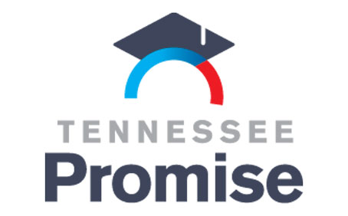
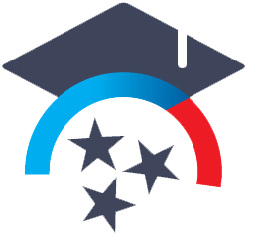
TN Promise

TN Promise will provide two years of tuition-free attendance at a community or technical college in Tennessee.

Fall 2023 - Continuing Students Dates to Remember
By December 1:
Complete and report eight (8) hours of community service to your partnering organization to maintain eligibility into the spring 2024 semester.
** Click here to see where you should submit your service hours based on your home county.

By April 15:
Submit the 2024-25 Free Application for Federal Student Aid (FAFSA) at www.studentaid.gov. The 2023-24 FAFSA will be available in December 2023.

* Because the FAFSA is different this year, the usual TN Promise deadlines are also a little different. The 2024-25 FAFSA will open sometime in December 2023.

Where you can get Community Service Hours:
TN Achieves website breaks down what you need to know about community service hours and the TN Promise Scholarship. Here’s what they say below:

WHAT COUNTS AS COMMUNITY SERVICE?
Community service is time contributed to a nonprofit or public service organization. The community should be benefitting from the work you do!
Students can also volunteer in their field of interest to gain experience. This means that job shadowing may count toward your community service requirement.
Make sure you are volunteering with an actual organization (not an individual), you are not being paid or working at your job off the clock, you are being supervised by someone who is not a family member and your activity does not include proselytizing (sharing faith).

What does count:
- Tutoring students at a community center
- Doing laundry for residents of a nursing home
- Working with an organization to build homes for people in need
- Participating in an environment clean-up event
- Volunteering to work at a booth for a food drive or charity race
- Volunteering with established student organizations at your college
What doesn’t count:
- Building a deck with your friend
- Babysitting
- Picking up trash during a hike with friends
- Donating cans to a food drive or running a race
- Proselytizing (sharing faith)
HOW DO I SUBMIT MY COMMUNITY SERVICE HOURS?
Where you need to submit community service hours depends on what county you are from. Some counties (including Claiborne County) will submit through the Ayers Foundation. Other counties not listed with the Ayers Foundation will use TN Achieves. Check the TN Promise website page here to verify which organization you will log your hours through.

TN Promise Institutions
Here’s a list of all the institutions that accept TN Promise, from a booklet found on the TN Promise website.

All TCATS are eligible for TN Promise

TN Community Colleges:

- Chatanooga State Community College
- Cleveland State Community College
- Columbia State Community College
- Dyersburg State Community College
- Jackson State Community College
- Motlow State Community College
- Nashville State Community College
- Northeast State Community College
- Pellissippi State Community College
- Roan State Community College
- Southwest Tennessee Community College
- Volunteer State Community College
- Walters State Community College

Tennessee Promise at Four-Year Institutions:
“In order to use the Tennessee Promise scholarship at a four-year college or university, students must enroll in an associate degree program at that school – not a bachelor’s degree program. A list of associate degree programs at each eligible four-year institution across the state is below for your reference. Students enrolling in a health sciences program will only begin receiving funds once admitted into the actual program of study.

At a four-year institution, the Tennessee Promise scholarship will not be last-dollar, meaning it will not cover all tuition and fees. The amount of funding you will receive will be based on the average amount of tuition and fees at a community college, which is estimated to be $4,000. As a last-dollar scholarship, Tennessee Promise will provide whatever amount remains after your Pell, HOPE, and TSAA funds are applied. For example, if you were to receive $3,000 in HOPE funds, but no other federal or state financial aid, Tennessee Promise would provide $1,000 to cover the remaining amount that you could apply toward tuition and fees at a four-year school.”

PUBLIC UNIVERSITIES WITH ELIGIBLE TWO-YEAR PROGRAMS:
- Austin Peay State University
- Tennessee State University

PRIVATE COLLEGES WITH ELIGIBLE TWO-YEAR PROGRAMS:
- Baptist College of Health Science
- Bethel University
- Bryan College
- Carson-Newman University
- Christian Brothers University
- Cumberland University
- Freed-Hardman University
- John A. Gupton College
- Johnson University
- King University
- Lane College
- Lee University
- LeMoyne-Owen College
- Lincoln Memorial University
- South College
- Southern Adventist University
- Trevecca Nazarene University
- Tusculum University
- Welch College
- William R. Moore College of Technology

