Alumni Blog from September 2022

FAQ Student Loan Forgiveness
This page will be constantly updated as new information is released

President Biden's announcement to forgive federal student loan debt (up to $20,000 for Pell Grant recipients and up to $10,000 for others who qualify) is leaving many of us with unanswered questions, and some of the details won't be clear for weeks...perhaps even months.
This action also extends the pause on monthly student loan payments, which means borrowers won't have to resume payments until at least January, and provides details on a new proposal to create a more affordable income-driven repayment plan.
We know that you are left with tons of questions about the cancellation program. Who is eligible? Do you have to apply? We have done a deep dive and here is some information that we currently have.
​
Who qualifies for loan cancellation?
Individuals who are single and earn under $125,000 will qualify for the $10,000 debt cancellation. If you're married and file your taxes jointly or are "head of household", you qualify if your income is under $250,000.
Eligibility will be based on your adjusted gross income. Income figures from either 2020 or 2021 will determine if you are eligible.
If you received a Pell Grant and meet these income requirements, you could qualify for an extra $10,000 in cancellation.
Only loans disbursed by June 30th of this year are eligible for relief.
​

Did I receive a Pell Grant?
There is a good chance you received one as part of your financial aid package while in college. If you are unsure, check your account on studentaid.gov. On the main page of your account, there's a section titled "My Aid".
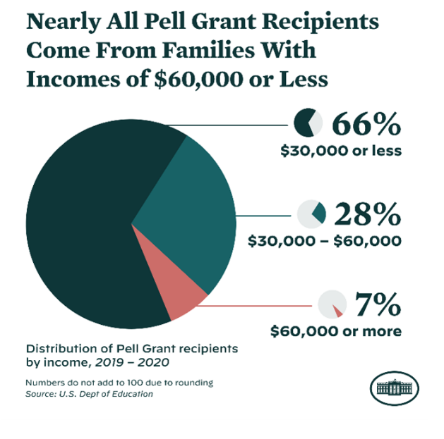

​
​
​

​
​
​
​
​
​
​
​
​
I only have graduate school debt, but I got a Pell Grant when I was an undergraduate. Am I eligible for the extra $10,000?

Yes.

I had a Pell Grant for only one year. Am I eligible for the extra $10,000?

Yes.

I qualified for only a partial Pell Grant. Am I eligible for the extra $10,000?

Yes.

Which types of debt qualify?
The vast majority will be eligible for the forgiveness based on their loan type because their debt is under what is called the William D. Ford Federal Direct Loan Program. That includes Direct Stafford Loans, and all Direct Subsidized and Unsubsidized federal student loans. Under the Direct program, Parent Plus and Grad Loans are also eligible for the relief.
As of September 30th, there has been a significant reversal that will affect many student loan borrowers. The U.S. Department of Education has quietly changed its guidance around who qualifies for the student debt relief plan.
At the center of this change are borrowers who took out federal student loans many years ago with Perkins and Federal Family Education Loans. FFEL loans, issued and managed by private banks but guaranteed by the federal government, were once the main source of the federal student aid program until the FFEL ended in 2010.
According to federal data, more than 4 million borrowers still have FFEL loans. Until September 30th, the department's own website advised these borrowers to consolidate these loans into federal Direct Loans so they could qualify for relief under the debt cancellation program.
However, they have now changed the language. The guidance now says, "As of September 29, 2022, borrowers with federal student loans not held by ED cannot obtain one-time debt relief by consolidating these loans into Direct Loans."

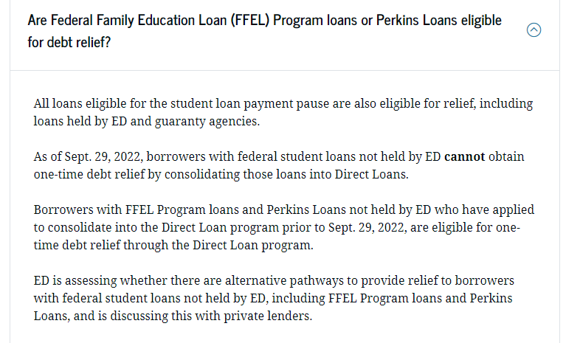

According to NPR, administration officials say that this change will not affect all 4 million borrowers with commercially-held FFEL loans. Those borrowers who also have Direct Loans can still qualify to consolidate their FFEL loans, though that detail was not included in the department's updated guidance.
Ultimately, this change will affect roughly 800,000 borrowers.
It's unclear why the department reversed its decision on allowing FFEL borrowers with commercially-held loans to consolidate and then qualify for debt relief. It may be that the policy changed out of concern that private banks that manage old FFEL loans could potentially file lawsuits to stop the debt relief, arguing that Biden's plan would cause them financial harm.
When FFEL borrowers consolidate their old loans into federal Direct Loans, these private banks essentially lose business. If the banks' financial health depends on the assumption that they would be holding and profiting from these debts over the long-term, then losing borrowers to the debt relief plan could, possibly, harm those banks.

​
I was a student this year. Do I qualify?
Yes. But if you were a dependent during the 2021-2022 school year, eligibility depends on parental income, not your own.
If your status changed in the middle of this year- say, because you graduated- the department has administrative data for many people that will allow it to recognize the change. If it doesn't have that data, there will be a process by which you can prove your change in status.

When is the loan cutoff date for cancellation?
Student loans taken out after June 30, 2022 won't be included in the relief.

Are parent loans eligible?
Yes. The federal Parent Plus Loans are eligible.

Are graduate student loans eligible?
Yes, Plus loans are also available for graduate students, and these, too, are eligible.
​

I didn't finish my degree. Does that disqualify me?
No.

What's the first thing I need to do if I qualify?
Start by making sure that your loan servicer knows how to find you, so that you'll be able to receive any guidance it provides and follow any instructions that it issues. Check that your postal address, your email address and your mobile phone number are listed accurately.
If you don't know who your servicer is, consult the Department of Education's "Who is my loan servicer?" web page for instructions.

How do I apply for student loan forgiveness? Or does it happen automatically?
It depends. If you're already enrolled in some kind of income-driven repayment plan and have submitted your most recent tax return to certify that income, your loan servicer and the Education Department know how much you earn and you should not need to do anything else. Still, keep an eye out for guidance from your servicer. Close to eight million borrowers "may" be eligible to get this automatic relief, according to the department.
For everyone else, the department intends to have a "simple" application available by early October. You can sign up to receive an alert when it's ready. It's fine to apply even if you think the department has your latest tax information.
The department will stop taking applications on December 31, 2023.

When will loan forgiveness start?
Once you apply, it should be no more than six weeks until your balance falls by whatever amount your eligible for.
​A tip: The payment pause that has been in effect since 2020 is supposed to expire at the end of the year. So, you should have an application in by early November to get your relief before the bills start coming again.

How can I be sure that the cancelation has really happened?
Watch for messages from your loan servicer and be diligent. Given how many millions of people are involved and that billions of dollars are at stake, there are bound to be hiccups. If you get a message that you suddenly have a zero balance or that your balance has fallen by $10,000 or $20,000, take a screen shot and print it out just in case it somehow changes later.
​If your debt goes to zero, keep an eye on your credit report in the months afterwards to make sure that your loan servicer is reporting that fact correctly. For instance, there should not be any notices of late payments that post after your balance shows at zero.
​
​
​
​
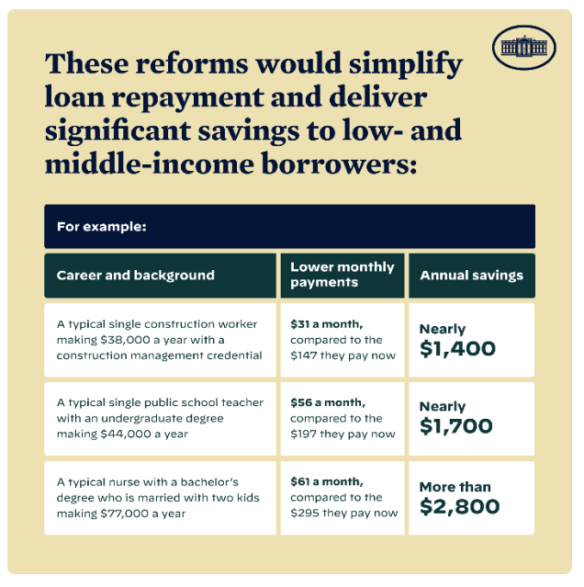
​
​
​
​
​
​
​
​
​
​
​

Will the loan forgiveness trigger taxes?
Student loan forgiveness won't trigger a federal tax bill.
That's because the American Rescue Plan of 2021 made student loan forgiveness tax free through 2025- and the law covers Biden's forgiveness.
You may, however, still be on the hook for state levies.
Some states automatically conform to federal rules, but others may count the forgiven balance as income, meaning it's still possible you'll have a state bill. The amount "may be equivalent of a few student loan payments".
According to the Tax Foundation, 13 states could treat Biden's student loan forgiveness initiative as taxable income to borrowers. The states are Arkansas, Hawaii, Idaho, Kentucky, Massachusetts, Minnesota, Mississippi, New York, Pennsylvania, South Carolina, Virginia, West Virginia, and Wisconsin. The Tax Foundation estimates that borrowers could incur anywhere from $300 to over $1,000 in state taxes, depending on the specific state, if they receive $10,000 in student loan forgiveness. These figures could double for Pell Grant recipients, who are eligible to receive up to $20,000 in student loan forgiveness.
​Some of the states may act to avoid this, either administratively or legislatively. We saw this happen with the Paycheck Protection Program (PPP), which provided forgivable loans to small businesses during the Covid-19 pandemic. While PPP loan forgiveness was not taxed at the federal level, some states would have taxed it at the state level. However, a number of states- such as Virginia- wound up passing legislation to conform state law to federal law, at least for a period of time. It is quite possible that some states will engage in similar efforts this year to shield their residents from state taxation.
If you're unsure, contact a local tax professional for an estimate before filing your state tax return.

My debt exceeds the amount I am eligible to have cancelled, and my loans have been on pause since the relief began in March 2020. Will payments start again on my remaining balance?
Not until at least January.
​You should receive a billing notice at least 3 weeks before your first payment is due, but you can contact your loan servicer before then (online is more efficient) for specifics on what you owe and when payment is due.
I have more than $10,000 in debt. When and how will my monthly payment amount be adjusted?
Payments will be recalculated. Specifics of this have not been released yet, but we can make a guess based on what is possible now.
​When borrowers pay a solid chunk of debt and their balance declines, they can ask their servicer to recalculate their payments over the remaining loan term, resulting in a lower monthly payment. If the $10,000 in forgiveness doesn't dent into a borrower's balance, the payments may stay the same. Borrowers already enrolled in income-driven plans, however, generally won't see their payments change- even if a portion of their debt is canceled. This is because they make payments based on their income and household size.

What if I want to keep paying the same amount and have it applied to the principal?
Send in the extra money with your on-time payment each month.
​If your payment drops to $200 a month after forgiveness, but you had been paying $300, continue paying that $300. The first $200 will be applied to the payment that is due and the extra $100 will be applied to the principal.
​It's always a good idea to log into your account to be sure the extra money is being applied to the principal and not next month's statement or your interest.

What if I still can't afford to pay my loans? What are my options?
There are several repayment options to consider, each with different eligibility rules and conditions. In many cases, struggling borrowers will probably want to opt for an income-driven repayment plan, where the payment amount is tied to your income and can as low as $0. After you make payments for a set period of years, whatever balance remains is forgiven by the federal government.
​Other repayment plans may better suit your circumstances, and they can sometimes have lower payment amounts. Those include the standard (with fixed payments), graduated (your payments rise), and extended (you pay over a long period of time) repayment plans.
​Options that pause payments altogether should generally be used only as a last resort: Requesting a deferment or forbearance will temporarily put payments on hold, but there can be significant added costs in the long run. With forbearance, payments stop but interest still accrues. If the interest is not paid, it's added to the loan's principal balance. Deferment is similar, but subsidized loans- which generally have slightly better terms- won't accrue interest while they're paused.

Do I qualify for forgiveness if my loans were in default?
Yes. All defaulted borrowers who benefited from the payment freeze are eligible for relief. That includes those that have federal direct loans; Federal Family Education Loans, both privately held and government owned; and Perkins loans held by the government.

My debt exceeds $10,000 and my loans were in default. What does this mean for me?
You'll get a fresh start! Your loans are now deemed current, which means you can enroll into a repayment plan without having to jump through the extra hurdles usually required.
​If you still cannot afford to make payments, call your servicer, who can assist with enrolling you into a more affordable repayment program, including income- driven repayment. If you take no action, you will simply fall into default again. It often takes a year or more for an account to move into collections. At that point, the federal government can take your tax refund, up to 15% of your paycheck or part of your Social Security benefits.
​The new status also means defaulted borrowers are no longer cut off from receiving federal student aid, including Pell grants.

Has anything else changed?
Yes. In April, the Education Department said it would make fixes to address past inaccuracies that would help borrowers enrolled in Income Driven Repayment Plans, including a one-time revision that would make more payments count toward loan forgiveness. That includes:
- Any months in which borrowers made payments will count toward Income Driven Repayment, regardless of the repayment plan.
- All payments made on loans that were later consolidated will count.
- Months spent in deferment before 2013 (with the exception of school deferment) will count.
- Forbearance of more than 12 consecutive months and 36 cumulative months will also count toward forgiveness, under both Income Driven Repayment plan and the Public Service Loan Forgiveness plan.
​In 2023, the government will begin displaying payment counts on studentaid.gov so borrowers can view their progress in their own accounts.

How does this overlap with the recent changes to the Public Service Loan Forgiveness?
The cancelation should happen independently of any process that you're already going through to get partial or complete cancelation via Public Service Loan Forgiveness.
​There is currently a limited-time waiver for public servants that will allow a number of people to get credit toward loan cancelation for past payments that would not have otherwise qualified. You can learn more by visiting the Public Service Loan Forgiveness Waiver page on the Department of Education's website.
​The deadline for applying for the waiver is October 31st.
Will debt relief become a regular thing?
Don't count on it. The Education Department confirmed that the Biden student loan forgiveness initiative is a one-time opportunity, so borrowers should not expect this to happen again.

For more information see the White House Fact Sheet.
​
​
​Updated Information
​In October, the US Department of Education will launch a short online application for student debt relief. You won't need to upload any supporting documents or use your FSA ID to submit your application.
Once you submit your application, they will review it, determine your eligibility for debt relief, and work with your loan servicer(s) to process your relief. They will contact you if they need any more information from you.
​
What's Next?
​Right now, you don't need to do anything! The Department of Education will contact you when the sign-up period for student debt relief opens. They will continue to send regular updates with more details over the coming days, as we near the application period, which will begin in October 2022 and last through December 2023.
​
Beware of Scams
​You might be contacted by a company saying they will help you get loan discharge, forgiveness, cancellation, or debt relief for a fee. You never have to pay for help with your federal student aid. Make sure you work only with the U.S. Department of Education and their loan servicers, and never reveal your personal information or account passwords to anyone.
​The Department of Education's emails to you come from noreply@studentaid.gov, noreply@debtrelief.studentaid.gov, or ed.gov@public.govdelivery.com. You can report scam attempts to the Federal Trade Commission by calling 1-877-382-4357 or visit reportfraud.ftc.gov.
​
Sources:
https://www.npr.org/2022/09/29/1125923528/biden-student-loans-debt-cancellation-ffel-perkins
https://www.nytimes.com/2022/08/24/business/biden-student-loan-forgiveness.html
https://www.cnbc.com/2022/08/26/more-details-emerge-about-biden-federal-student-debt-forgiveness-plan.html
https://www.forbes.com/sites/adamminsky/2022/08/29/bidens-student-loan-forgiveness-could-be-taxable-in-some-states/?sh=472d638b67fb

Last Updated: 9/30/2022

